
San Francisco Bay University

CE450 Fundamentals of Embedded Engineering
Lab 10 555 Timer

Objectives:
Students will design the program to control 555 timer through GPIO ports on Raspberry Pi bord and do hands-on exercise through lab assignments

Introduction:
If you ask anyone in the know to rank the most commonly and widely used IC, the famous 555 timer base IC would certainly be at the top of the list. The 555 - a mixed circuit composed of analog and digital circuits - integrates analogue and logical functions into an independent IC, and hence tremendously expands the application range of analog integrated circuits. The 555 is widely used in various timers, pulse generators, and oscillators.

Equipment:
The equipment you require is as follows:
- Laptop & Raspberry Pi 3 model Board
- SunFounder Super Starter Kit V2.0 for Raspberry Pi
- NE555

The Laboratory Procedure:
- Hardware connection
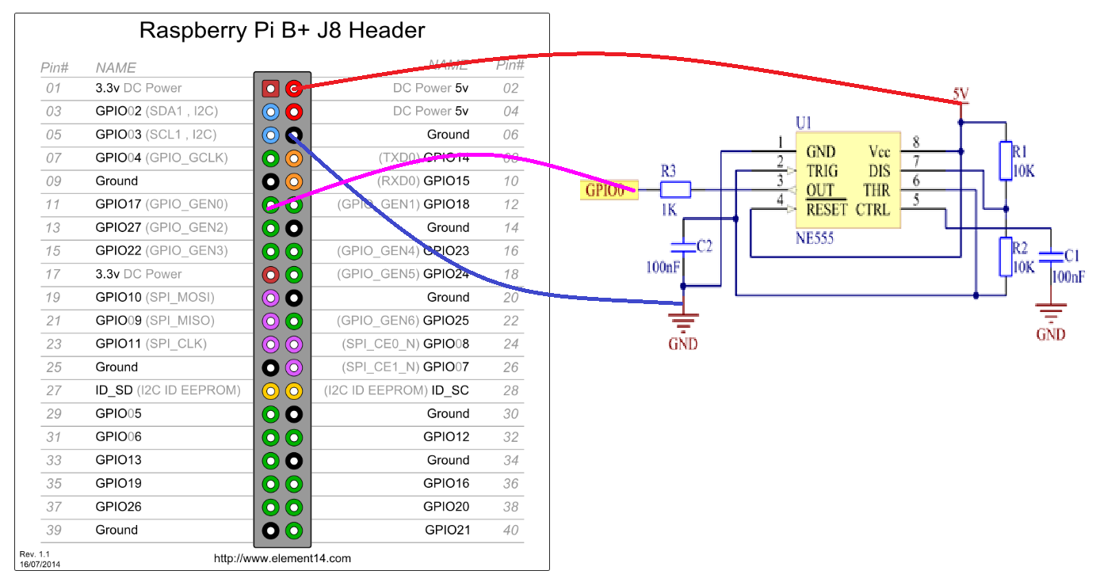
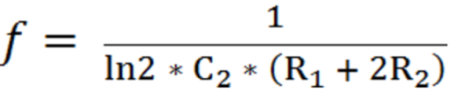
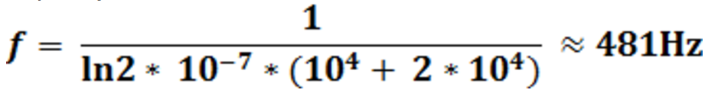
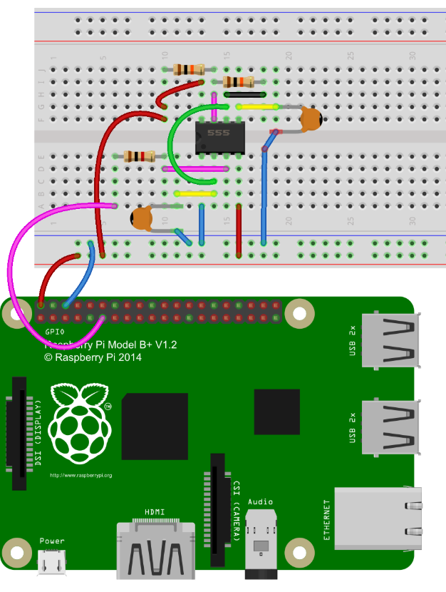

- Control program in Python

# Python Program

import RPi.GPIO as GPIO

SigPin = 11 # pin11

g_count = 0

def count(ev=None):
global g_count
g_count += 1

def setup():
GPIO.setmode(GPIO.BOARD) # Numbers GPIOs by physical location
GPIO.setup(SigPin, GPIO.IN, pull_up_down=GPIO.PUD_UP)
# Set Pin's mode is input, and pull up to high level(3.3V)
GPIO.add_event_detect(SigPin, GPIO.RISING, callback=count)
# wait for rasing

def loop():
while True:
print('g_count = %d' % g_count)

def destroy():
GPIO.cleanup() # Release resource

setup()
try:
loop()
except KeyboardInterrupt: # When 'Ctrl+C' is pressed, the child program destroy() will be executed.
destroy()

*Note: Hardware connection reference and running command
https://learn.sunfounder.com/lesson-9-ne555/
https://learn.sunfounder.com/category/super-kit-v3-0-for-raspberry-pi/

The Laboratory Assignments:

- Build up the hardware circuit and run the example program to observe what will happen

